



<https://www.getpostman.com/>

下載安裝檔

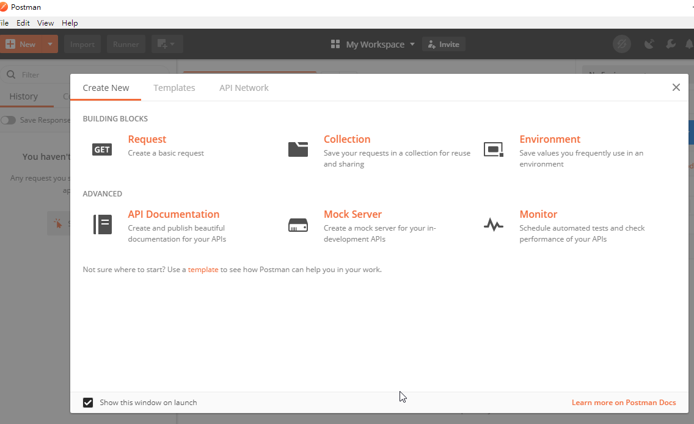

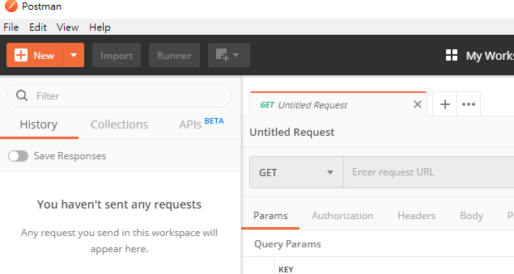

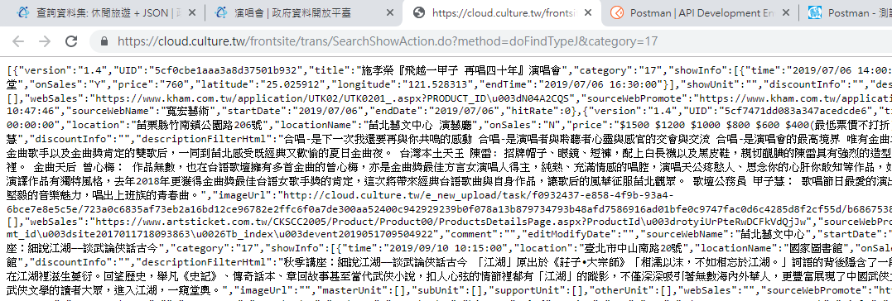

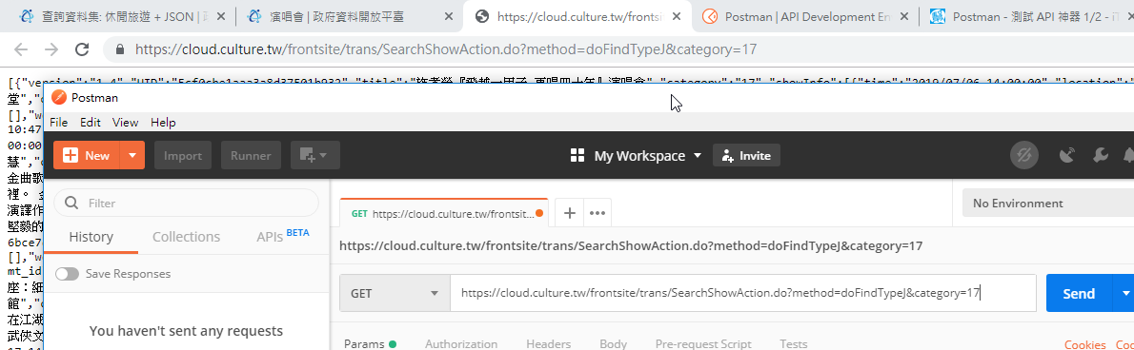

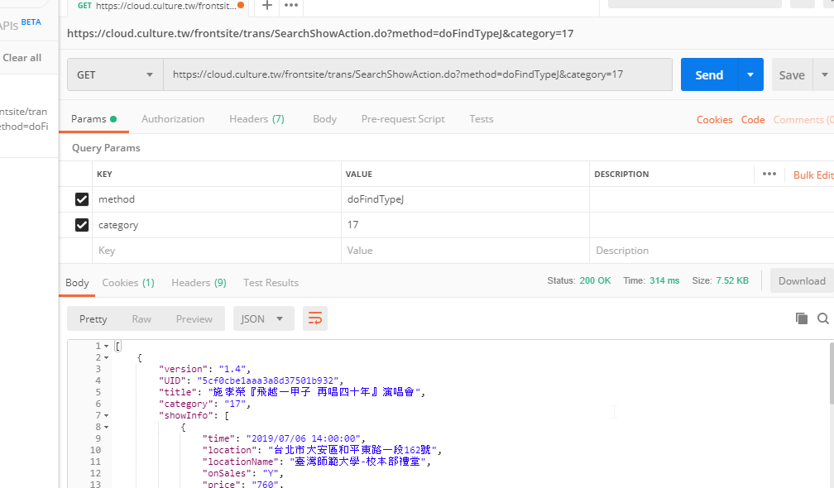

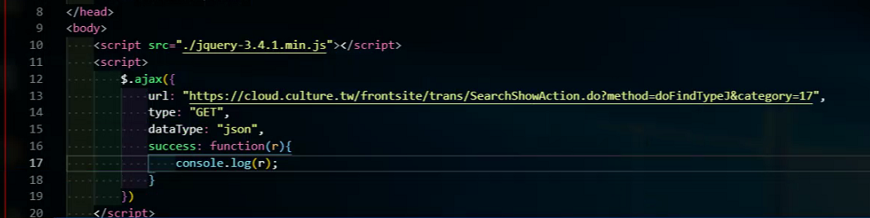

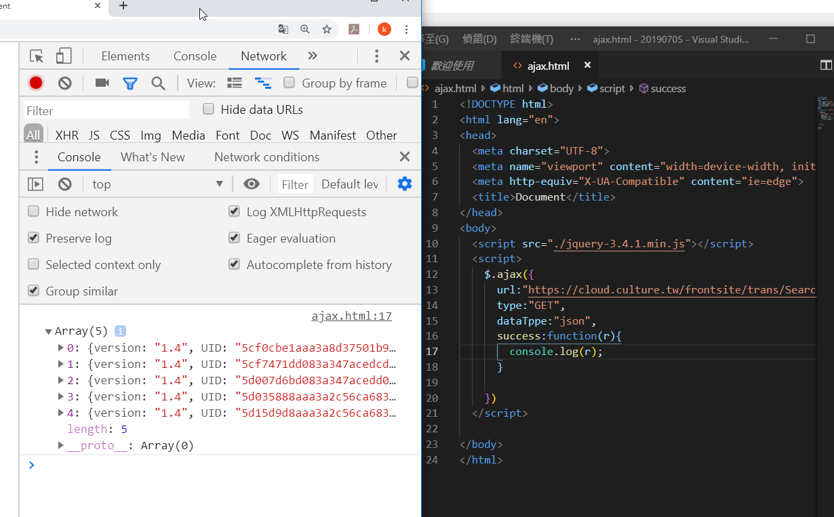

<script src="./jquery-3.4.1.min.js"></script>

<script>

$.ajax({

url:"https://cloud.culture.tw/frontsite/trans/SearchShowAction.do?method=doFindTypeJ&category=17",

type:"GET",

dataTppe:"json",

success:function(r){

console.log(r);

}

})

</script>

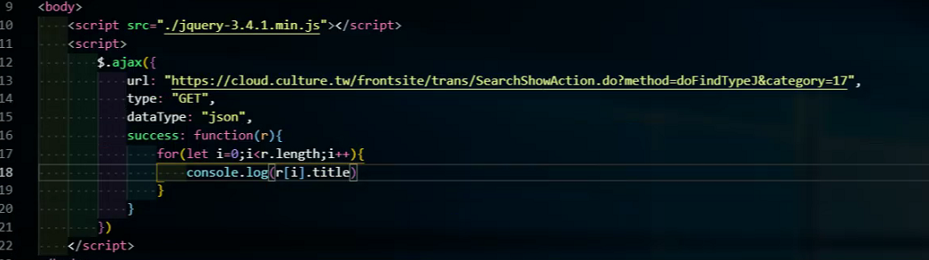

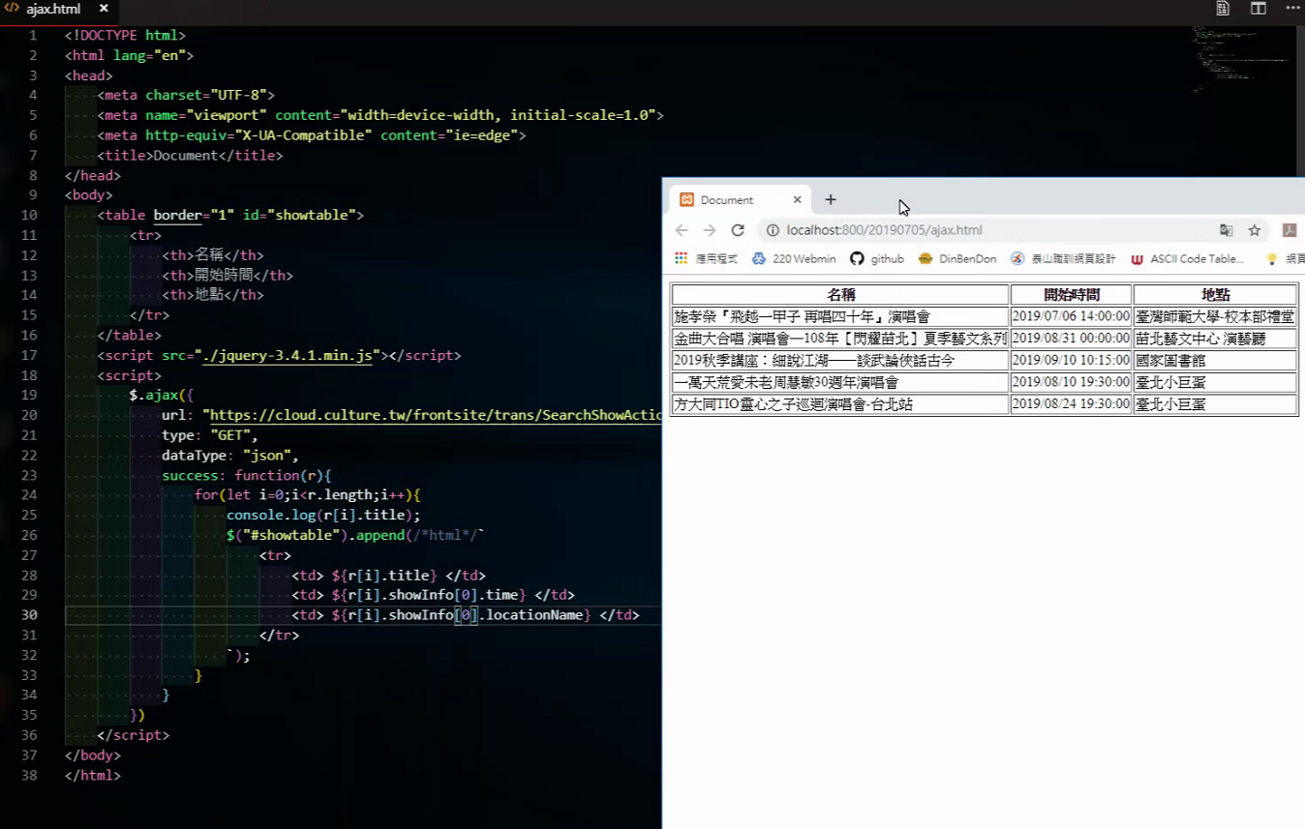

<!DOCTYPE html>

<html lang="en">

<head>

<meta charset="UTF-8">

<meta name="viewport" content="width=device-width, initial-scale=1.0">

<meta http-equiv="X-UA-Compatible" content="ie=edge">

<title>Document</title>

</head>

<body>

<table border="1" id="showtable">

<tr>

<th>名稱</th>

<th>開始時間</th>

<th>地址</th>

</tr>

</table>

<script src="./jquery-3.4.1.min.js"></script>

<script>

$.ajax({

url:"https://cloud.culture.tw/frontsite/trans/SearchShowAction.do?method=doFindTypeJ&category=17",

type:"GET",

dataTppe:"json",

success:function(r){

//console.log(r);

for(let i=0;i<r.length;i++){

console.log(r[i].title);

$("#showtable").append(/*html*/`

<tr>

<td>${r[i].title} </td>

<td>${r[i].showInfo[0].time} </td>

<td>${r[i].showInfo[0].locationName} </td>

</tr>

`);

}

}

})

</script>

</body>

</html>

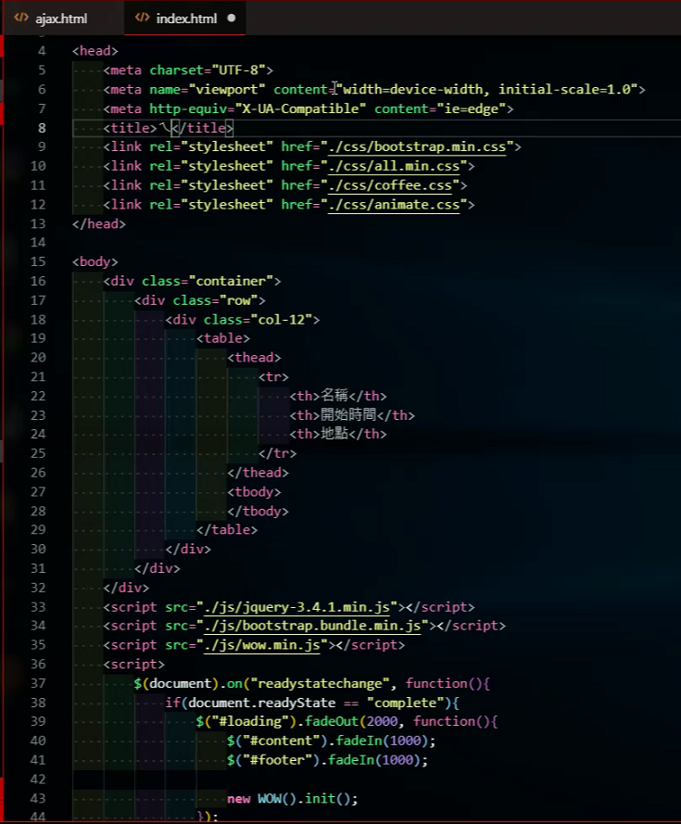

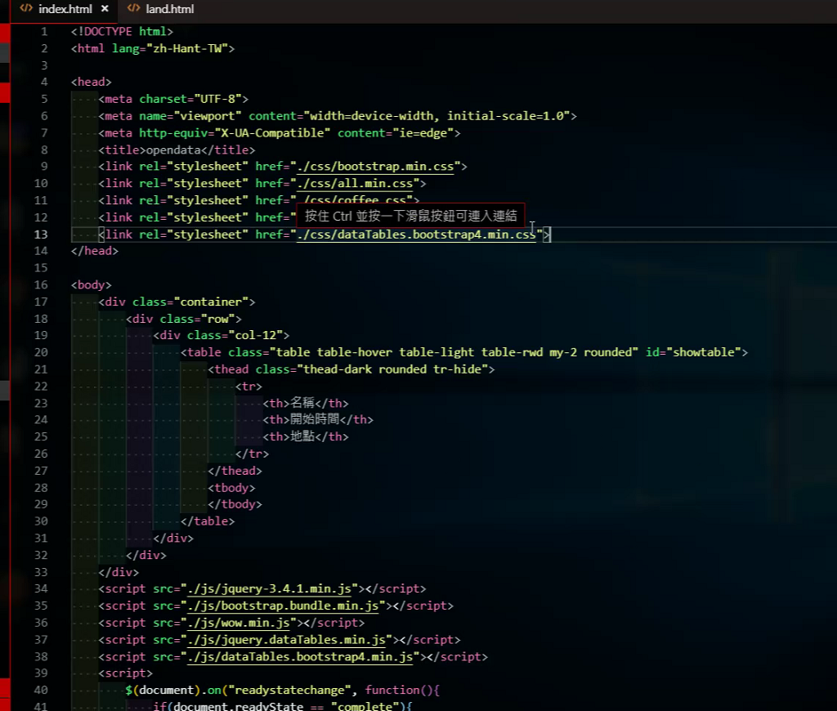

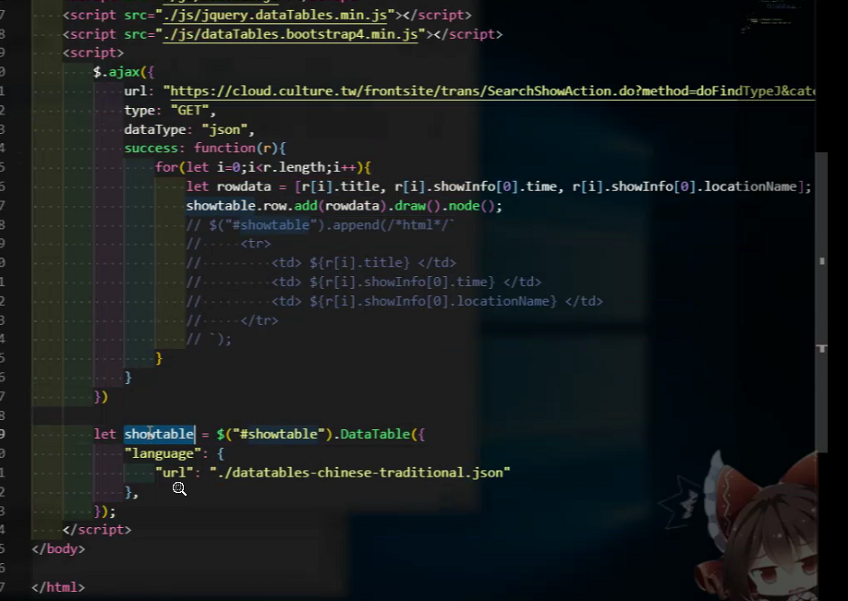

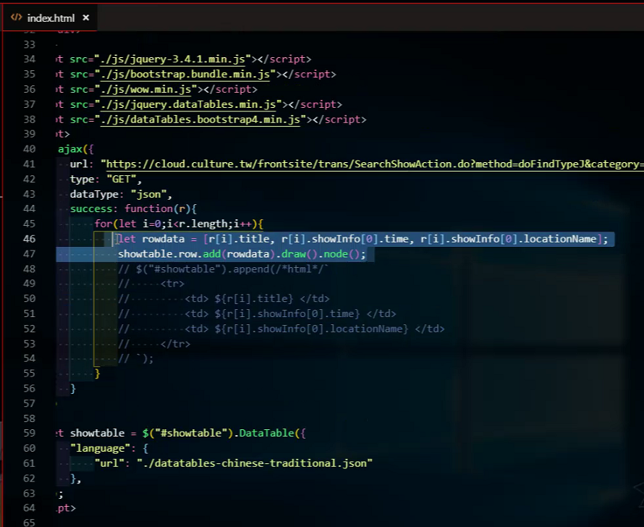

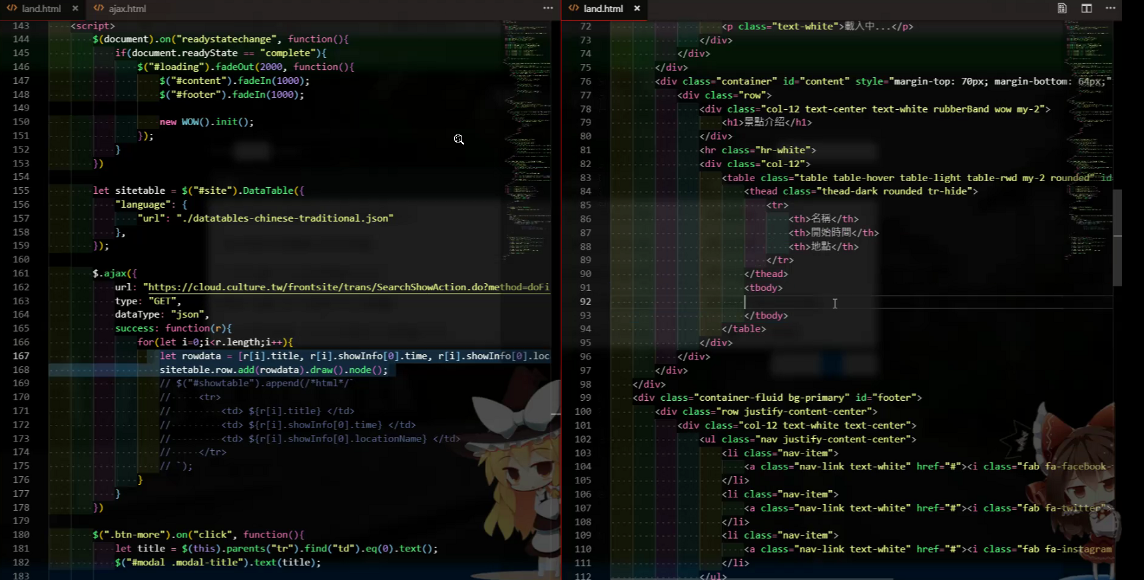

對格式的標籤很要求

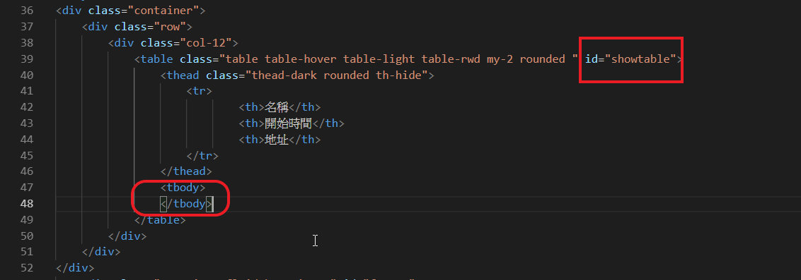

<body>

<div class="container">

<div class="row">

<div class="col-12">

<table class="table table-hover table-light table-rwd my-2 rounded " id="showtable">

<thead class="thead-dark rounded th-hide">

<tr>

<th>名稱</th>

<th>開始時間</th>

<th>地址</th>

</tr>

</thead>

<tbody>

</tbody>

</table>

</div>

</div>

</div>

<script src="./js/jquery-3.4.1.min.js"></script>

<script src="./js/bootstrap.bundle.min.js"></script>

<script src="./js/wow.min.js"></script>

<script src="./js/jquery.dataTables.min.js"></script>

<script src="./js/dataTables.bootstrap4.min.js"></script>

<script>

$.ajax({

url:"https://cloud.culture.tw/frontsite/trans/SearchShowAction.do?method=doFindTypeJ&category=17",

type:"GET",

dataTppe:"json",

success:function(r){

//console.log(r);

for(let i=0;i<r.length;i++){

let rowdata = [r[i].title, r[i].showInfo[0].time, r[i].showInfo[0].locationName];

showtable.row.add(rowdata).draw().node();

// console.log(r[i].title);

// $("#showtable").append(/*html*/`

// <tr>

// <td>${r[i].title} </td>

// <td>${r[i].showInfo[0].time} </td>

// <td>${r[i].showInfo[0].locationName} </td>

// </tr>

// `);

}

}

})

let showtable = $("#showtable").DataTable({

"language":{

"url": "./datatables-chinese-traditional.json"

}

})

</script>

</body>

<https://fullcalendar.io/>

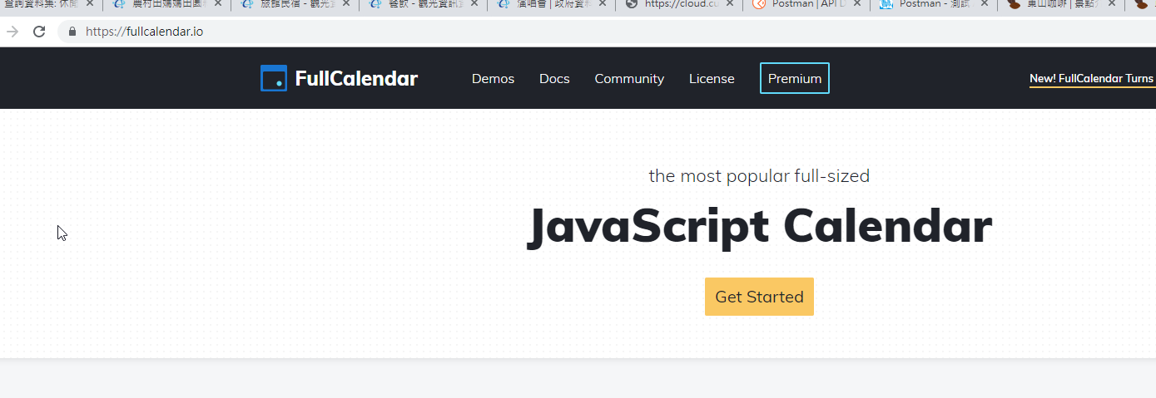

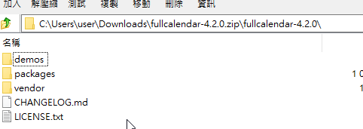

Packages下

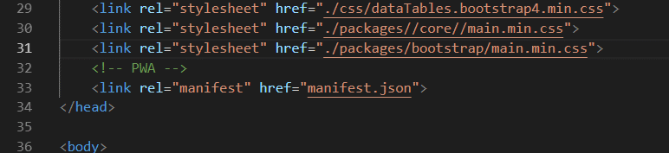

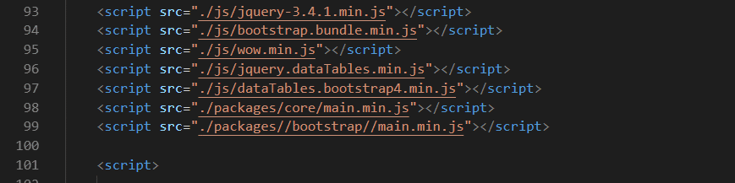

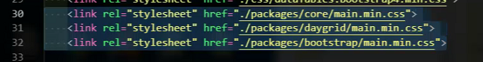

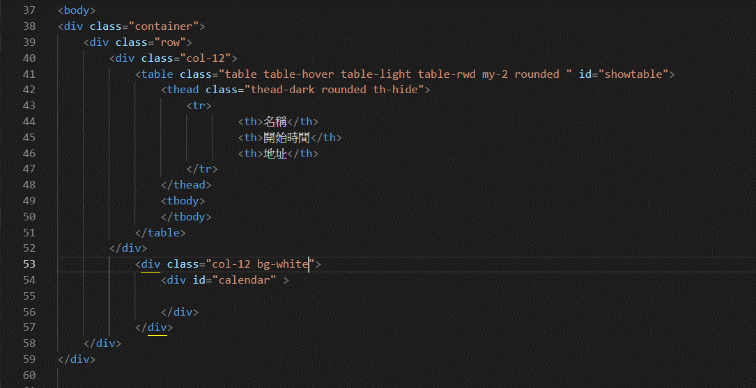

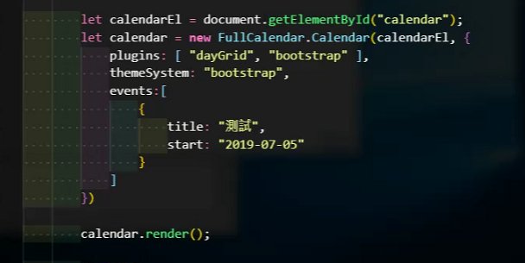

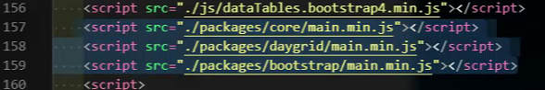

<link rel="stylesheet" href="./css/bootstrap.min.css">

<link rel="stylesheet" href="./css/all.min.css">

<link rel="stylesheet" href="./css/coffee.css">

<link rel="stylesheet" href="./css/animate.css">

<link rel="stylesheet" href="./css/dataTables.bootstrap4.min.css">

<link rel="stylesheet" href="./packages/core//main.min.css">

<link rel="stylesheet" href="./packages/daygrid/main.min.css">

<link rel="stylesheet" href="./packages/bootstrap/main.min.css">

<!-- PWA -->

<link rel="manifest" href="manifest.json">

</head>

bg-white <div id="calendar" >

<body>

<div class="container">

<div class="row">

<div class="col-12">

<table class="table table-hover table-light table-rwd my-2 rounded " id="showtable">

<thead class="thead-dark rounded th-hide">

<tr>

<th>名稱</th>

<th>開始時間</th>

<th>地址</th>

</tr>

</thead>

<tbody>

</tbody>

</table>

</div>

<div class="col-12 bg-white">

<div id="calendar" >

</div>

</div>

</div>

</div>

<script src="./js/jquery-3.4.1.min.js"></script>

<script src="./js/bootstrap.bundle.min.js"></script>

<script src="./js/wow.min.js"></script>

<script src="./js/jquery.dataTables.min.js"></script>

<script src="./js/dataTables.bootstrap4.min.js"></script>

<script src="./packages/core/main.min.js"></script>

<script src="./packages/daygrid/main.min.js"></script>

<script src="./packages/bootstrap/main.min.js"></script>

<script>

let calendarEl = document.getElementById("calendar");

let calendar = new FullCalendar.Calendar(calendarEl, {

plugins: ["dayGrid", "bootstrap"],

themeSystem: "bootstrap",

events:[

{

title: "測試",

start: "2019-07-05"

}

]

})

calendar.render();

$.ajax({

url:"https://cloud.culture.tw/frontsite/trans/SearchShowAction.do?method=doFindTypeJ&category=17",

type:"GET",

dataTppe:"json",

success:function(r){

//console.log(r);

for(let i=0;i<r.length;i++){

let rowdata = [r[i].title, r[i].showInfo[0].time, r[i].showInfo[0].locationName];

showtable.row.add(rowdata).draw().node();

// console.log(r[i].title);

// $("#showtable").append(/*html*/`

// <tr>

// <td>${r[i].title} </td>

// <td>${r[i].showInfo[0].time} </td>

// <td>${r[i].showInfo[0].locationName} </td>

// </tr>

// `);

}

}

})

let showtable = $("#showtable").DataTable({

"language":{

"url": "./datatables-chinese-traditional.json"

}

})

</script>

</body>

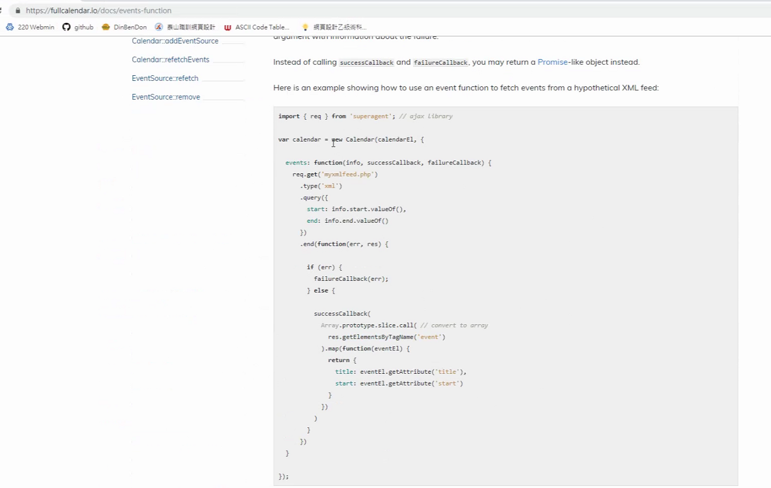

日曆格式只吃 –

/ 要轉- ,取代兩次

let start = r[i].startDate.replace("/","-").replace("/","-");

<link rel="stylesheet" href="./css/bootstrap.min.css">

<link rel="stylesheet" href="./css/all.min.css">

<link rel="stylesheet" href="./css/coffee.css">

<link rel="stylesheet" href="./css/animate.css">

<link rel="stylesheet" href="./css/dataTables.bootstrap4.min.css">

<link rel="stylesheet" href="./packages/core//main.min.css">

<link rel="stylesheet" href="./packages/daygrid/main.min.css">

<link rel="stylesheet" href="./packages/bootstrap/main.min.css">

<!-- PWA -->

<link rel="manifest" href="manifest.json">

</head>

<body>

<div class="container">

<div class="row">

<div class="col-12">

<table class="table table-hover table-light table-rwd my-2 rounded " id="showtable">

<thead class="thead-dark rounded th-hide">

<tr>

<th>名稱</th>

<th>開始時間</th>

<th>地址</th>

</tr>

</thead>

<tbody>

</tbody>

</table>

</div>

<div class="col-12 bg-white">

<div id="calendar" >

</div>

</div>

</div>

</div>

<script src="./js/jquery-3.4.1.min.js"></script>

<script src="./js/bootstrap.bundle.min.js"></script>

<script src="./js/wow.min.js"></script>

<script src="./js/jquery.dataTables.min.js"></script>

<script src="./js/dataTables.bootstrap4.min.js"></script>

<script src="./packages/core/main.min.js"></script>

<script src="./packages/daygrid/main.min.js"></script>

<script src="./packages/bootstrap/main.min.js"></script>

<script src="./packages/core/locales-all.min.js"></script>

<script>

$(document).on("readystatechange", function(){

if(document.readyState == "complete"){

$("#loading").fadeOut(2000, function(){

$("#content").fadeIn(1000);

$("#footer").fadeIn(1000);

new WOW().init();

});

}

})

$.ajax({

url:"https://cloud.culture.tw/frontsite/trans/SearchShowAction.do?method=doFindTypeJ&category=17",

type:"GET",

dataTppe:"json",

success:function(r){

//console.log(r);

let events =[];

for(let i=0;i<r.length;i++){

let rowdata = [r[i].title, r[i].showInfo[0].time, r[i].showInfo[0].locationName];

showtable.row.add(rowdata).draw().node();

// console.log(r[i].title);

// $("#showtable").append(/*html*/`

// <tr>

// <td>${r[i].title} </td>

// <td>${r[i].showInfo[0].time} </td>

// <td>${r[i].showInfo[0].locationName} </td>

// </tr>

// `);

let start = r[i].startDate.replace("/","-").replace("/","-");

events.push({

title:r[i].title,

start:start,

url:r[i].webSales

})

}

let calendarEl = document.getElementById("calendar");

let calendar = new FullCalendar.Calendar(calendarEl, {

locale:"zh-tw",

plugins: ["dayGrid", "bootstrap"],

themeSystem: "bootstrap",

events:events

/* events:[

{

title: "測試",

start: "2019-07-05",

color: "#00",

url: "https://www.kham.com.tw/application/UTK02/UTK0201_.aspx?PRODUCT_ID=N04A2CQS"

}

] */

});

setTimeout(function(){

calendar.render();

}, 2000)

}

})

let showtable = $("#showtable").DataTable({

"language":{

"url": "./datatables-chinese-traditional.json"

}

})

</script>

</body>

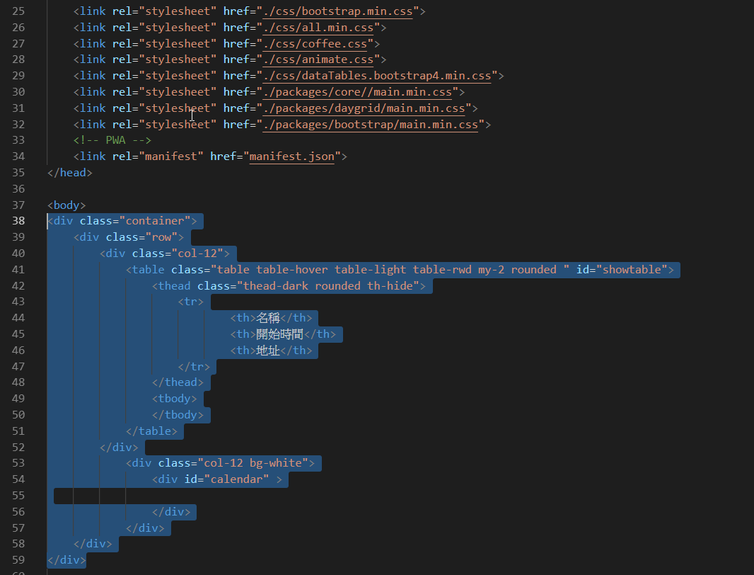

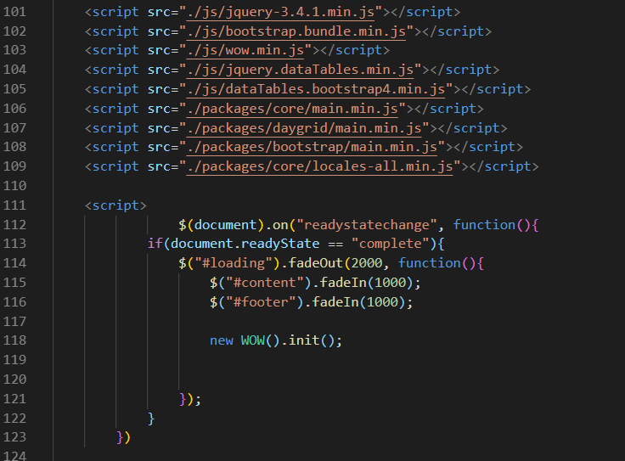

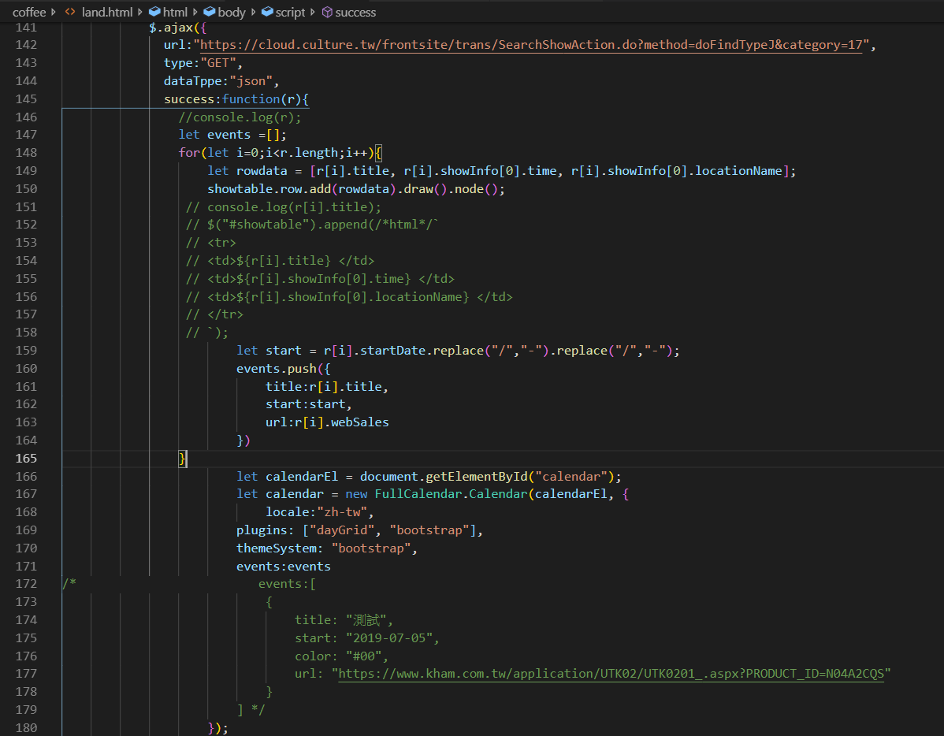

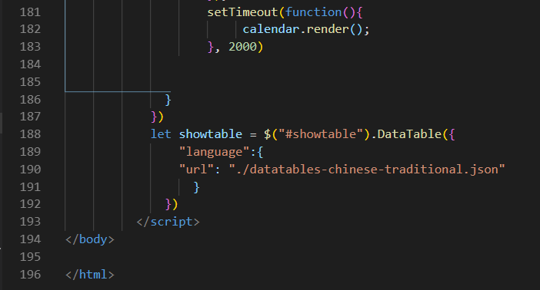



<https://github.com/chartjs/Chart.js/releases/tag/v2.8.0>

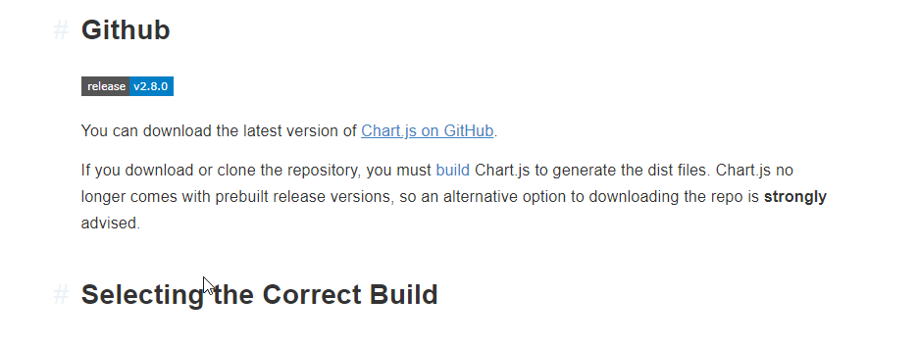

<https://www.chartjs.org/docs/latest/getting-started/installation.html>

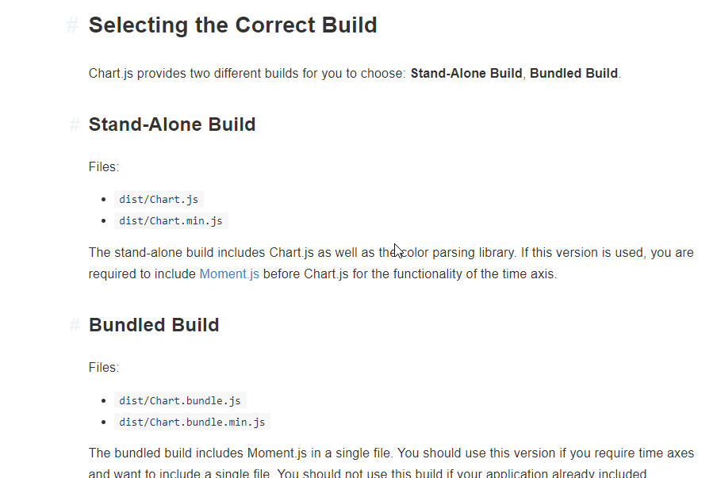

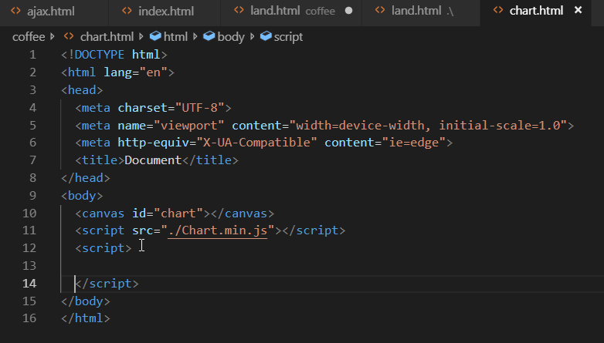

<https://www.chartjs.org/docs/latest/>

<!DOCTYPE html>

<html lang="en">

<head>

<meta charset="UTF-8">

<meta name="viewport" content="width=device-width, initial-scale=1.0">

<meta http-equiv="X-UA-Compatible" content="ie=edge">

<title>Document</title>

</head>

<body>

<div style="width:800px; height:500px">

<canvas id="chart"></canvas>

</div>

<script src="./Chart.min.js"></script>

<script>

/* getContext("2d") ,取得canvas 的繪圖參數 */

let ctx = document.getElementById("chart").getContext("2d");

let myLineChart = new Chart(ctx,{

type:"line",

data:{

labels:["第一期","第二期", "第三期", "第四期", "第五期" ],

datasets:[

{

label:"PHP網頁班",

data:[7,8,10,6,9]

},

]

}

})

</script>

</body>

</html>

Jq 用法

<!DOCTYPE html>

<html lang="en">

<head>

<meta charset="UTF-8">

<meta name="viewport" content="width=device-width, initial-scale=1.0">

<meta http-equiv="X-UA-Compatible" content="ie=edge">

<title>Document</title>

</head>

<body>

<div style="width:800px; height:500px">

<canvas id="chart"></canvas>

</div>

<script src="./Chart.min.js"></script>

<script src="./js/jquery-3.4.1.min.js"></script>

<script>

/* getContext("2d") ,取得canvas 的繪圖參數 */

//let ctx = document.getElementById("chart").getContext("2d");

let ctx = $("#chart");

let myLineChart = new Chart(ctx,{

type:"line",

data:{

labels:["第一期","第二期", "第三期", "第四期", "第五期" ],

datasets:[

{

label:"PHP網頁班",

data:[7,8,10,6,9]

},

]

}

})

</script>

</body>

</html>

//let ctx = document.getElementById("chart").getContext("2d"); **- >原生**

let ctx = $("#chart"); **->jq用法**

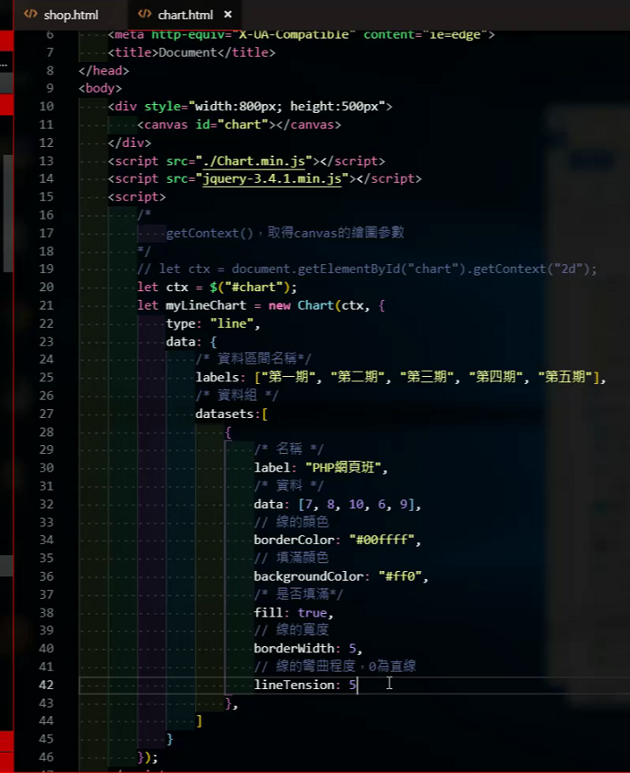

<body>

<div style="width:800px; height:500px">

<canvas id="chart"></canvas>

</div>

<script src="./Chart.min.js"></script>

<script src="./js/jquery-3.4.1.min.js"></script>

<script>

/* getContext("2d") ,取得canvas 的繪圖參數 */

//let ctx = document.getElementById("chart").getContext("2d");

let ctx = $("#chart");

let myLineChart = new Chart(ctx,{

type:"line",

data:{

labels:["第一期","第二期", "第三期", "第四期", "第五期" ],

datasets:[

{

label:"PHP網頁班",

data:[7,8,10,6,9],

borderColor:"#00ffff",

backgroundColor:"#f00",

fill:true,

borderWidth:5,

lineTension:0

},

]

},

options:{

title:{

text:"職訓課程乙級通過人數",

display:true

}

}

})

</script>

</body>

</html>

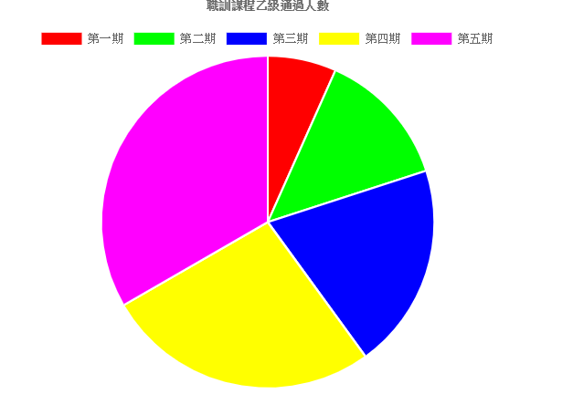

let ctx = $("#chart");

let myPieChart = new Chart(ctx,{

type : "pie",

data:{

datasets:[{

data:[10,20,30,40,50],

backgroundColor:["#f00","#0f0","#00f","#ff0","#f0f"]

}],

labels:["第一期","第二期", "第三期", "第四期", "第五期" ]

},

options:{

title:{

text:"職訓課程乙級通過人數",

display:true

}

}

})

擋跨域

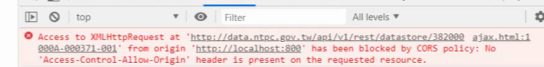

<https://developer.mozilla.org/zh-TW/docs/Web/HTTP/Headers/User-Agent>

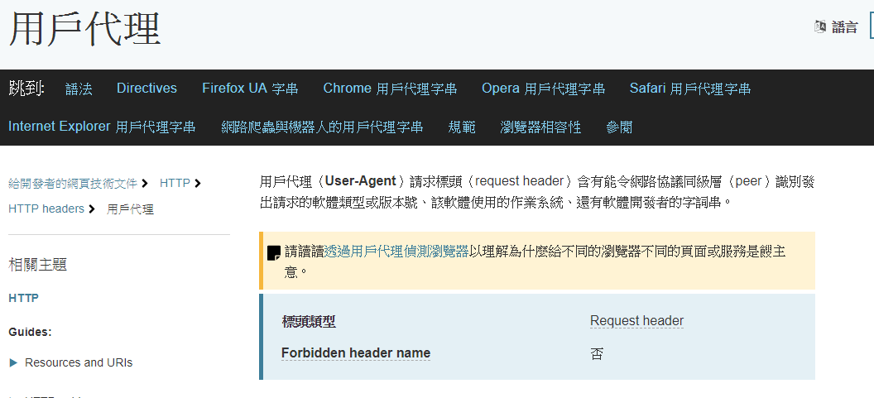



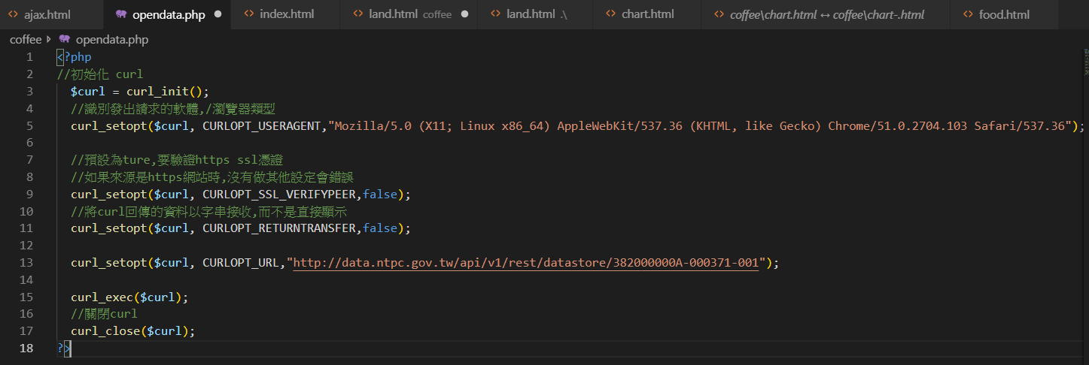

<?php

//初始化 curl

$curl = curl_init();

//識別發出請求的軟體,/瀏覽器類型

curl_setopt($curl, CURLOPT_USERAGENT,"Mozilla/5.0 (X11; Linux x86_64) AppleWebKit/537.36 (KHTML, like Gecko) Chrome/51.0.2704.103 Safari/537.36");

//預設為ture,要驗證https ssl憑證

//如果來源是https網站時,沒有做其他設定會錯誤

curl_setopt($curl, CURLOPT_SSL_VERIFYPEER,false);

//將curl回傳的資料以字串接收,而不是直接顯示

curl_setopt($curl, CURLOPT_RETURNTRANSFER,false);

curl_setopt($curl, CURLOPT_URL,"http://data.ntpc.gov.tw/api/v1/rest/datastore/382000000A-000371-001");

curl_exec($curl);

//關閉curl

curl_close($curl);

?>

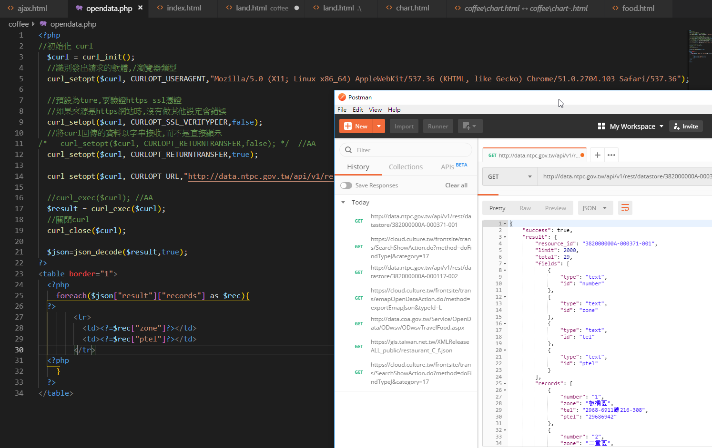

<https://data.gov.tw/dataset/32120>

<http://data.ntpc.gov.tw/api/v1/rest/datastore/382000000A-000371-001>

# 新北市各區公所民政(役政)災防課聯絡電話

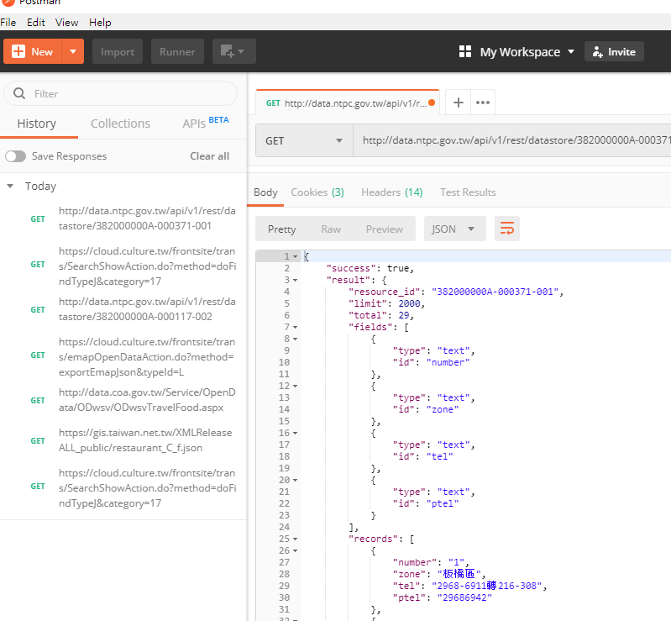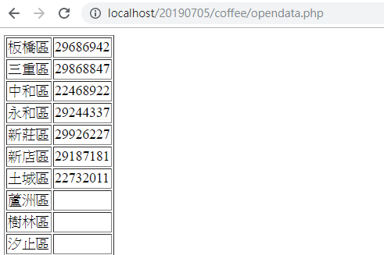

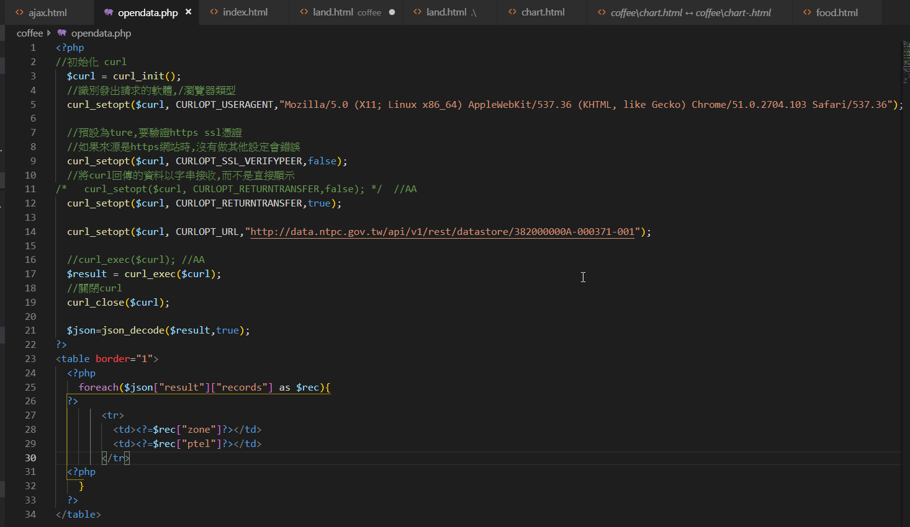

<?php

//初始化 curl

$curl = curl_init();

//識別發出請求的軟體,/瀏覽器類型

curl_setopt($curl, CURLOPT_USERAGENT,"Mozilla/5.0 (X11; Linux x86_64) AppleWebKit/537.36 (KHTML, like Gecko) Chrome/51.0.2704.103 Safari/537.36");

//預設為ture,要驗證https ssl憑證

//如果來源是https網站時,沒有做其他設定會錯誤

curl_setopt($curl, CURLOPT_SSL_VERIFYPEER,false);

//將curl回傳的資料以字串接收,而不是直接顯示

/* curl_setopt($curl, CURLOPT_RETURNTRANSFER,false); */ //AA

curl_setopt($curl, CURLOPT_RETURNTRANSFER,true);

curl_setopt($curl, CURLOPT_URL,"http://data.ntpc.gov.tw/api/v1/rest/datastore/382000000A-000371-001");

//curl_exec($curl); //AA

$result = curl_exec($curl);

//關閉curl

curl_close($curl);

$json=json_decode($result,true);

?>

<table border="1">

<?php

foreach($json["result"]["records"] as $rec){

?>

<tr>

<td><?=$rec["zone"]?></td>

<td><?=$rec["ptel"]?></td>

</tr>

<?php

}

?>

</table>

<https://data.gov.tw/dataset/28318>

<http://data.ntpc.gov.tw/api/v1/rest/datastore/382000000A-000352-001>



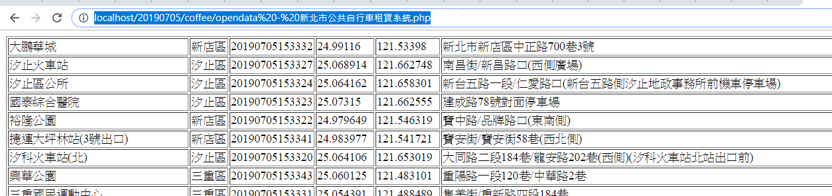

<http://data.ntpc.gov.tw/api/v1/rest/datastore/382000000A-000283-002>

<https://data.gov.tw/dataset/26694>



<http://data.ntpc.gov.tw/api/v1/rest/datastore/382000000A-000225-002>

<https://data.gov.tw/dataset/26653>



